PREPARE EMPATHY MAP
TASK-3

BY
M.MAHESWARI
952319104023

What is an empathy map and why create one?
An empathy map is a simple, easy-to-digest visual that captures knowledge about a user’s behaviors and attitudes. It is a useful tool to helps teams better understand their users. Empathy mapping is a simple holders, marketing and sales, product workshop activity that can be done with stakedevelopment, or creative teams to build empathy for end users. For teams involved in the design and engineering of products, services, or experiences, an empathy mapping session is a great exercise for groups to “get inside the heads” of users.

creating an effective solution requires understanding the true problem and the person who is experiencing it. The exercise of creating the map helps participants consider things from the user’s perspective along with his or her goals and challenges.

Empathy maps are most useful at the beginning of the design process after user research but before requirements and concepting. The mapping process can help synthesize research observations and reveabout a user’s al deeper insights needs. (The maps are most effective when based on research data, but like provisional personas, can be built using knowledge from internal participants or using existing personas.) It can help guide the construction of personas or serve as a bridge between personas and concept deliverables.

Benefits include
- Better understanding of the user
- Distilled information in one visual reference
- Callouts of key insights from research
- Fast and inexpensive
- Easily customizable based on available information and goals
- Common understanding among teams.

How to create an empathy map
To create an empathy map, gather any qualitative research data, personas, and your team. The only materials needed are large sheets of paper or a whiteboard, colored sticky notes, and markers. You can freehand sketch your map or print worksheets from the many free templates available online. (I prefer to use the large, canvas-sized post-its and small stickies for effective group collaboration and reserve printed worksheets for individual exercises.)

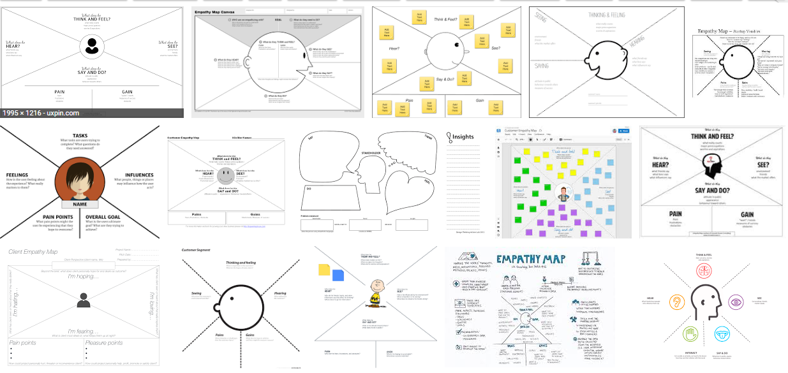
Elements and Steps
Empathy maps vary in formats, but they have common core elements. A large sheet of paper (or whiteboard sketch) is divided into sections with the user at the center. The representation of the user is often a large empty head. (Dave Gray, Xplaner founder and empathy map creator, originally called it, The Big Head Exercise.)

Around the user, the sheet is divided into sections or quadrants. Each section is labeled with a category that explores the user’s external, observable world, and internal mindset: what the user is doing, seeing, hearing, thinking, and feeling (including pains and gains). The group works together to fill in the information with their knowledge of the user and the data gathered through research.

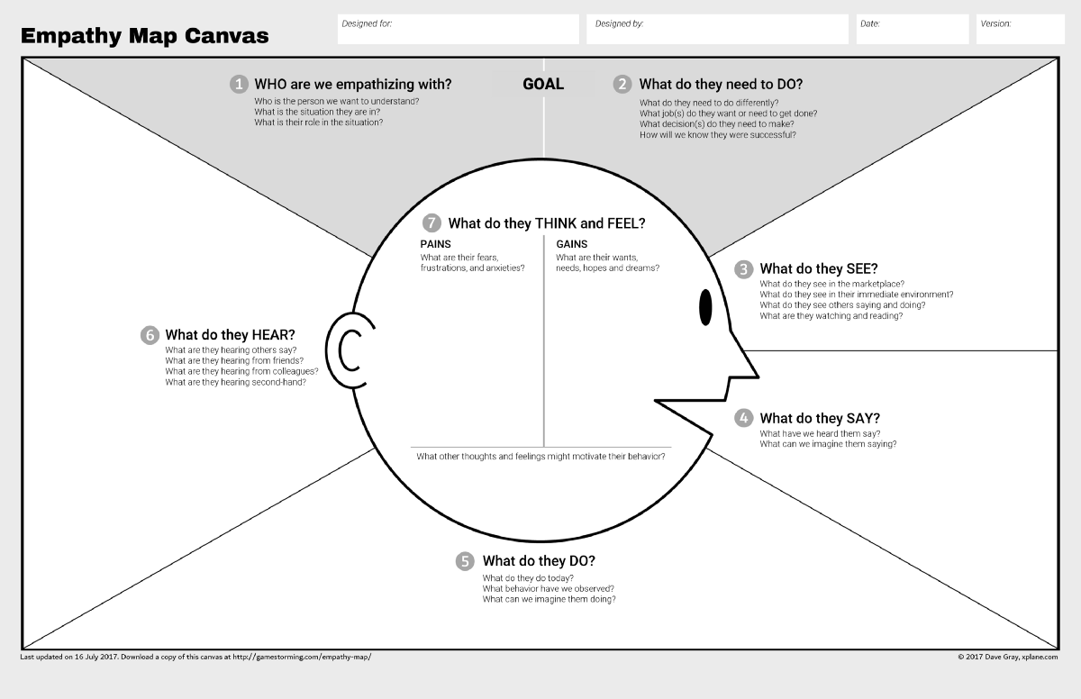

Step 1: Establish Focus and Goals
Who is the person for the map?
This is the user who you want to understand and empathize with. Summarize his or her situation and role. If you have multiple personas, each one will need their own map.

What is the desired outcome?
This is what you hope the user will do. What does success look like? For example, what does he or she need to do differently or decide? While the exercise is about building empathy and not selling or designing anything, answering this question helps focus participants and set context for the activity.

Step 2: Capture the Outside World
There’s no set order for completing each section, but I have found it more productive to start with the observable activities in the user’s world. Participants often generate these more easily than the more introspective steps. Start by examining the user’s experience and imagine what it is like to be her. Complete the sections of the map to capture what she sees, says, does, and hears.
Step 3: Explore Inside the Mind
After completing the outside elements, the focus moves inside the mind to explore the thoughts and feelings that are internal to the user and not observable. These might be inferred, guessed, or captured in direct quotes during research. This is the central point of the exercise, as teams imagine what it is like to be in someone else’s head.

